Please Print Your Full Contact Information
Please complete this confidential application in full and email this to sandy@onehearthealingcenter.com
by Wednesday October 22, 2014

Name_____________________________________________________________

Company Name____________________________________________________

Street Address______________________________________________________

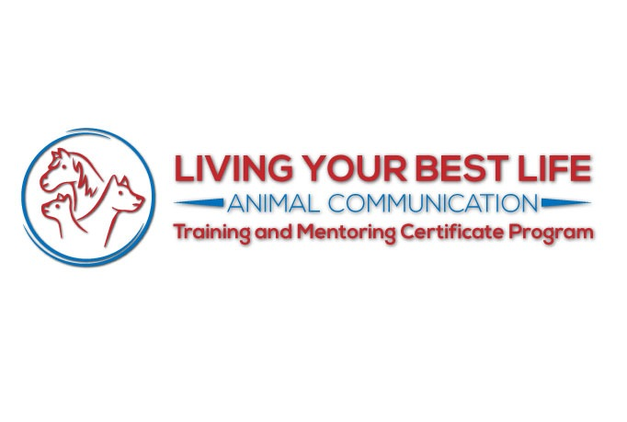
City/Town_________________________________________________________

State/Province___________________Zip______________Country___________

Primary Phone #____________________________________________________

Primary Email Address_______________________________________________

Website if applicable________________________________________________

Why is a coaching program right for you at this time?____________________

__________________________________________________________________

__________________________________________________________________

__________________________________________________________________

__________________________________________________________________

__________________________________________________________________

Are you interested in this coaching program for personal or for professionals reasons? And, what is your vision for how you will be incorporating this into your life personally and/or for work or business?

__________________________________________________________________

__________________________________________________________________

__________________________________________________________________

__________________________________________________________________

__________________________________________________________________

What are your top 3 goals that you would like to accomplish through this coaching program?
__________________________________________________________________

__________________________________________________________________

__________________________________________________________________

__________________________________________________________________

__________________________________________________________________
What do you feel are your 3 greatest strengths that you will bring to this coaching program?

__________________________________________________________________

__________________________________________________________________

__________________________________________________________________

__________________________________________________________________

__________________________________________________________________

List the 3 biggest obstacles where you feel you need the support of an Expert Mentor and Peer Support Group where you can get help to work through these over the next 6-8 months.

__________________________________________________________________

__________________________________________________________________

__________________________________________________________________

__________________________________________________________________

__________________________________________________________________

What is your animal communication process like now? And how would you like to improve upon this process?
__________________________________________________________________

__________________________________________________________________

__________________________________________________________________

__________________________________________________________________

How able, ready and willing are you to invest in yourself, your animals and animal related work right now - at home or professionally? Are you willing to do what it takes to practice and be able to take decisive, soul purpose driven action that will help you achieve the results you desire?

__________________________________________________________________

__________________________________________________________________

__________________________________________________________________

__________________________________________________________________

__________________________________________________________________

In what ways would you like to enhance the lives of animals and humans around you after going thru this program?
__________________________________________________________________

__________________________________________________________________

__________________________________________________________________

__________________________________________________________________

__________________________________________________________________

Thank you for taking the time for yourself, your animals, and animal work to submit this application. Include anything else you’d like to add.

__________________________________________________________________

__________________________________________________________________

__________________________________________________________________

__________________________________________________________________
Are You Ready For Extraordinary Growth?
Living The Best Life Possible with Your Animals, While Moving Forward in Your Work, Your Life, and in the World ~ with 7 Months of Incredible Training and Support?

Please choose which program you are interested in:
Please note that space in the 1:1 program is extremely limited.

Group Program________
Individual with Group _________

Sandy will contact applicants to set up a brief phone appointment to go over your application. Payment and options will be reviewed also. Deposits for those accepted will be due at that time. Those who are accepted will be notified shortly.

** Please note: Your completed application must be completed and returned by Wednesday October 22, 2014

Terms and Conditions

Thank you for your application. I will personally review each application and contact you soon to let you know if you have been accepted. If you are accepted, we will process your full deposit based on the program(s). We will also send you all the details for the Live Your Best Life Coaching and Mentoring Program or Private Coaching.

Please know that this is a non-cancelable commitment. There are no refunds or cancellations for deposits, full or monthly payments of the program.

I am really looking forward to working with you!

Love, and to Living The Best Possible Life with Your Animals!
Sandy

